**Issues:** Jobs

**Keywords:**

| employ, employer, employment, career, occupation, work, profession, job, recruit, recruitment, hiring, employment opportunity, part-time job, full-time job, temporary job, remote work |
| --- |

**What are respondents of this category saying in Q1-5?**

**Removed words:** 'community', 'town', 'small', 'people', 'college', 'grinnell', 'job'



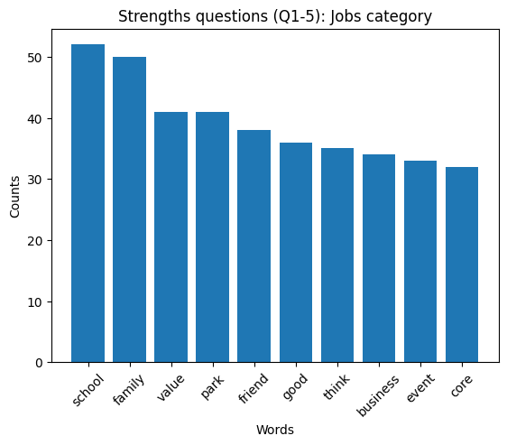

**Average sentiment of respondents of this category:**

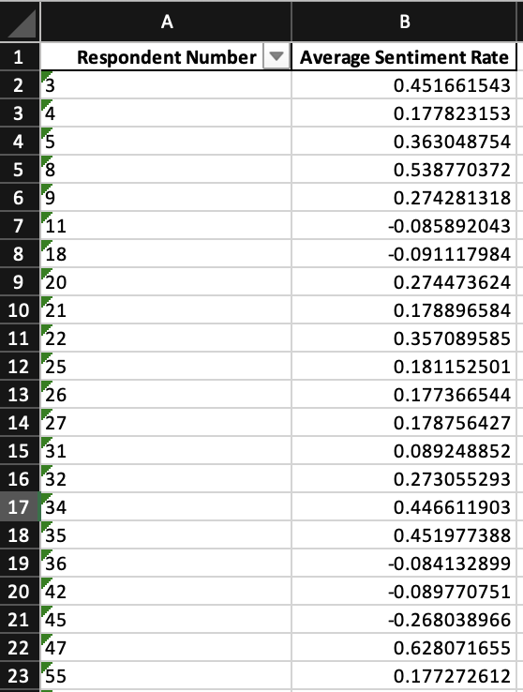

**Full file at: Final Deliverable > Issues Analysis & Deliverables > average_sentiment_jobs.xlsx**

**Clusterings based on response to each question:**

Question 1: What makes you glad to live in Grinnell?

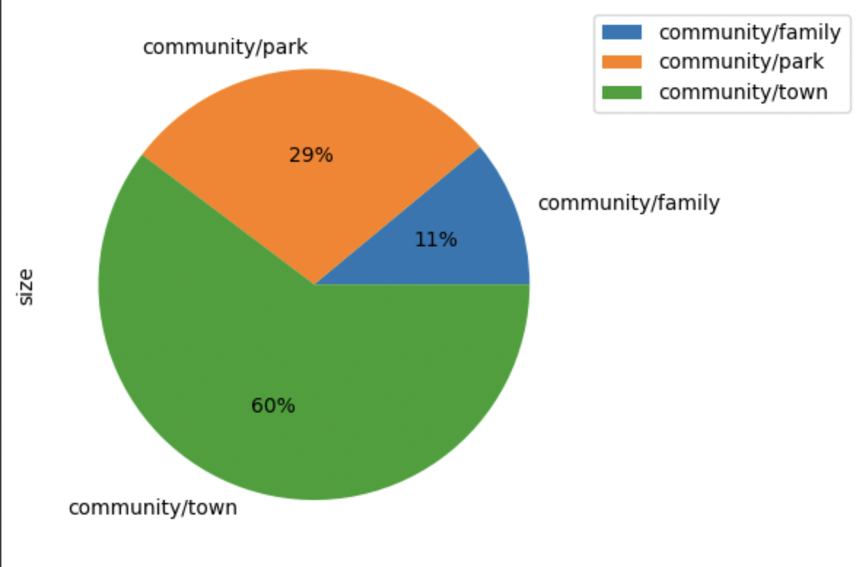

Question 2: What things have the greatest positive impact on your quality of life in Grinnell?

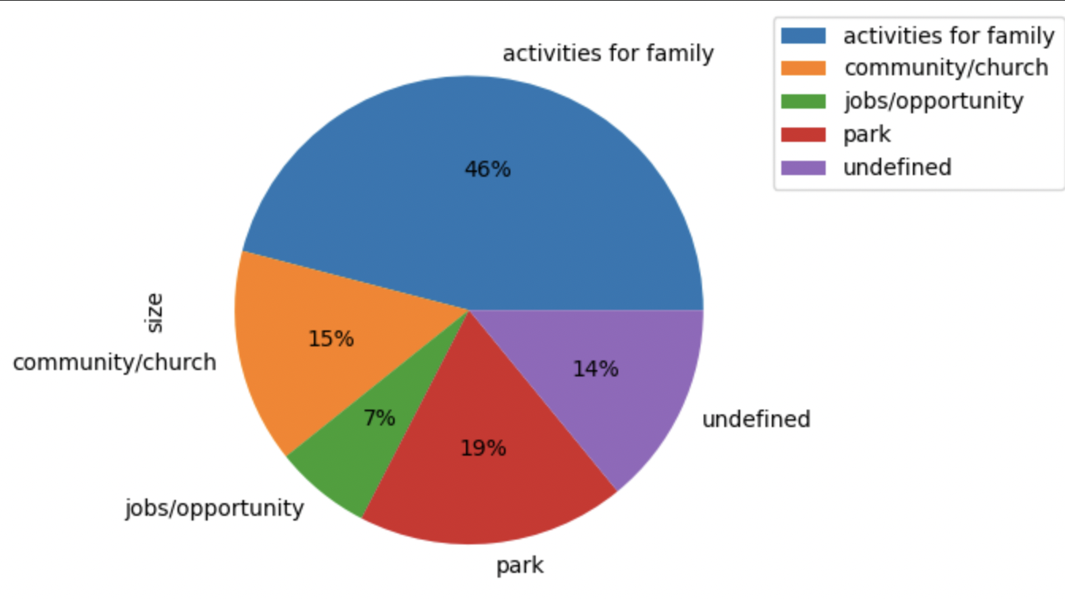

Question 10: What things have the greatest positive impact on your quality of life in Grinnell?

